Autonomous InfraRed Image Sensing Robot (AIRIS – R)

|  |  |  |
| --- | --- | --- |
| Aditya Godambe | Ashutosh Mahajan | Chinmay Karanjkar |

## Problem Definition

Autonomous InfraRed Image Sensing Robot, aka, AIRIS – R is an Autonomous Obstacle Detection and Identification Robotic Car.

## Project Scope

AIRIS – R is designed to work with none to minimal human interference. The Robot is designed to detect known obstacles while it travels over a defined guideway. Navigation of the car is controlled by Infrared sensors. The prime feature of the robotic car is to detect obstacles in front of the robot. Machine Learning is used to train the processor to categorize the obstacles into the pre-defined categories after which control signals are generated and the interfacing medium controls the hardware (DC motors and Servo motor). The Robotic Car is also designed to detected signals and some of the road signs. The Robot will start its motions and will stop after it detects any obstacle; then it will analyze the surrounding. ­­

## System Architecture

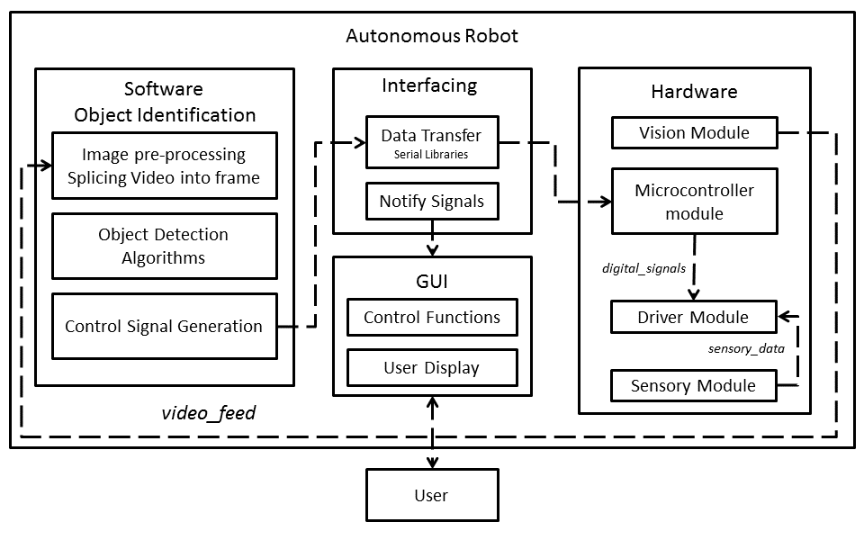

## Brief Description

Image Video feed is taken from the Vision Module of the Robot, which is then passed to the main Image Processing Module. Here, algorithms like Background Subtraction (for mobile obstacles), Bag of Features algorithm for Image Classification and Identification, basic color detection algorithms for signal detection and Canny edge detection for identification of other obstacles.

Ultrasonic sensors and IR sensors are used for navigation and going around the obstacle after it is detected. Ultrasonic sensors tell the robot that it is out of the range of the obstacle, and then it can return to its original path. It also provides a backup mechanism for obstacle detection if in case Image Sensing fails. A Control GUI is provided for the user to monitor the working of the robot and/or switch between Autonomous and Manual mode in case of technical difficulty.

System Flowchart

|  |  |
| --- | --- |
| C:\Users\User\Google Drive\BE Project\AIRIS-R\AIRIS-R (12).jpg  Side View | Top view |

# Conclusion

AIRIS-R Integrated Computer Vision and Machine Learning to enable autonomous behavior. It was found that the average accuracy of machine learning turned out to be 94%. It was also observed that the accuracy of the image classifier can be further improved with better hardware and using finer feature points.

AIRIS-R is proposed to be upgraded to GPS navigation. A stand-alone processor is to be used so as to minimize multiple processors that are currently being used. Efficiency of the Obstacle Identification algorithm is to be increased to obtain fast real-time response. Navigation using pre-fed Map Image is being designed to impart complete autonomy to the robot for advanced applications like Military Surveillance, Driverless Cars.